NOSEWORK SEMINAR WITH
MICHELE ELLERTSON

HOW TO SET HIDES TO HELP PROBLEM SOLVE
Pooling & trapping, close proximity and high hide challenges

SATURDAY SEPTEMBER 30TH NW3 & ABOVE
SUNDAY OCTOBER 1st Any dog below NW3 who is on Odor

Workshop Fees
Working: $175 per day (limited to 12 working dogs)
Auditing: $75 per day (no limit)

VENUE: The Peaks Retreat and Adventure Center
1336 Simmons Mill Road, Thaxton VA 24174
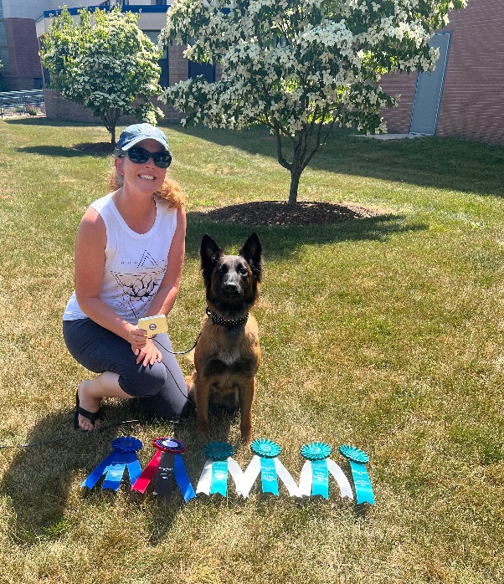
Michele has worked as a Professional Dog Trainer for over 20 years. Prior to being swept up in the Nosework craze, she worked mostly in behavior modification. In 2009, Michele was among the first dog trainers in New England to become involved in the National Association of Canine Scent Work’s (NACSW) sport of K9 Nosework. She currently works with the NACSW as a Certifying Official, Trial Representative, trial host, and competitor. It’s no secret the sport has skyrocketed, and Michele’s intense schedule of regular weekly classes, private lessons, specialty clinics, and new online virtual programs show it. In addition to having the honor of teaching at the National K9NW Camps she owns “The Dog’s PACE” out of Massachusetts, a school specializing in K9 Nosework.
Personally, Michele has taken 3 of her rescue dogs to the Elite level and competed in the 2015 and 2017 NACSW nationals with her 12 lb. Chihuahua/Terrier mix Hemi. Currently she is owned and loved by two dogs: Chaser, an 8 year old German Shepherd and Cannoli, a 2 year old Belgian Tervuren. Through a carefully laid foundation, Cannoli achieved her NW1 title at just over a year old with a third place, followed by her NW2, and 2 NW3 titles finishing first. Chaser
is happily enjoying his time training for his Elite Champion title. All her dogs have enjoyed multiple placements, high in trial, and pronounced notations.
Although her professional and personal interests have led Michele to train in a variety of dog sports, Michele’s fondness for Nosework comes from the tremendous benefits it offers to all dogs. From confidence building, bonding, mental stimulation, and pure enjoyment, this sport offers so much to both dog and handler.

For more information contact Ann Hogg at info@cannyk9companions.com

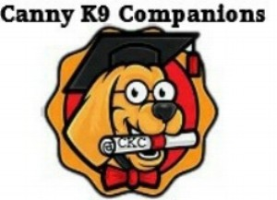
ANN HOGG CANNY K9 COMPANIONS
www.cannyk9companions.com

TRAINING WITH MICHELE ELLERTSON
September 30th & October 1st, 2023
The Peaks Retreat and Adventure Center
1336 Simmons Mill Road
Thaxton VA 24174

Working Team: $175 per day ☐ Saturday (NW3 & ABOVE) ☐ Sunday (any dog on odor below NW3 level)
Auditor: $ 75 per day ☐ Saturday ☐ Sunday

Water, hot drinks and snacks will be provided. You will need to bring your own lunch.

Payment must be made when the application is submitted. There is a $20 fee for any returned checks.

There will be no refunds unless a replacement can be found.
For more information email Ann at: info@cannyk9companions.com
Print, complete registration form, sign waiver and send with your payment to:
Ann Hogg
552 Parkview Drive
Blue Ridge VA 24064
Please make checks payable to Canny K9

Name:

Address:

City: State: Zip:

Cell Phone Number: _Email: ___________

Dog’s Name: Dog’s Training Level: ______________________

Disclaimer and Waiver of Liability

I hereby acknowledge that I have voluntarily signed up for a dog training seminar with Canny K9 Companions. I am aware that there are inherent risks and hazards involved with and around dogs, and I am voluntarily participating in the activities with the knowledge of these potential dangers. I am not relying on Canny K9 Companions LLC, the organizer, The Peaks Retreat and Adventure Center, Custom Ed., or the seminar presenter (Michele Ellerston) to prevent any loss or injury to myself or my dog(s). In order to participate in this Nose Work seminar, I, being fully informed of risks and hazards, agree to assume ALL RISK OF SUCH OCCURRENCE.

I hereby waive any and all claims or actions I or my guardians, representative or assigns may have against Canny K9 Companions LLC, and agree to release Canny K9 Companions LLC from liability in any and all personal injuries to myself, my dog(s), children in my charge, or harm to property causes directly or indirectly by any acts that might occur in conjunction with this dog Nose Work seminar or from the facility or grounds on which it sits, even if caused by alleged negligence by Canny K9 Companions LLC, visiting parties, or any other person(s).

I also agree to assume sole responsibility for injury or damage caused by myself, children in my charge, or by the dog I own or handle during participation in this seminar and further indemnify, defend, and hold Canny K9 Companions LLC harmless from any damage, loss, liability, or expense, including legal costs and attorney fees, which result from damage caused by myself, children in my charge, or the dog I own or handle.

RELEASE OF LIABILITY: I have carefully read this release of liability and fully understand the contents thereof. I am aware that this is a release of liability and a contract between Canny K9 Companions LLC and me, and I agree to it of my own free will.

I/we further agree that the trainers have the right to refuse training to any dog that repeatedly displays a vicious aggressive manner that is believed by the trainers not manageable by his/her owner or handler and that the trainers have the right to excuse any dog that appears in poor health.

I have read the above cancellation policy and I agree to all terms. I understand that there are no exceptions to the policy regardless of the reason for the cancellation. I understand that cancellation may result in my receiving NO REFUND if my spot cannot be filled from the waiting list. I also understand that I may not give nor sell my spot to another person.

(signature) (date)

R OA N O KE, VA (5 4 0) 5 2 4 8 3 7 2 WWW.C A N N Y K 9 C O M PA N I O N S. C O M (EM A I L T O : I N F O @ C A N N Y K 9 C O M PA N I O NS . C O M)

ASSUMPTION OF THE RISK AND WAIVER OF LIABILITY RELATING TO CORONAVIRUS/COVID-19

The novel Coronavirus (“COVID-19") has been declared a worldwide pandemic by the World Health Organization. COVID-19 is extremely contagious and is believed to spread mainly from person-to-person contact. As a result, federal, state, and local governments and federal and state health agencies have recommended social distancing and have, in many locations, prohibited or limited the congregation of groups of people. Canny K9 Companions, LLC, (hereinafter “CKC”), has put in place preventative measures to reduce the spread of COVID-19; however, CKC, cannot guarantee that you will not become infected with COVID-19. Further, attending and/or participating in a CKC class or seminar could increase your risk of contracting COVID-19.

By signing this document, I acknowledge the contagious nature of COVID-19 and voluntarily assume the risk that I may be exposed to or infected by COVID-19 as a result of attending and/or participating in a CKC class or seminar and that such exposure or infection may result in personal injury, illness, permanent disability, and death. I understand that the risk of becoming exposed to or infected by COVID-19 at a CKC class may result from the actions or inactions of myself or others. I voluntarily agree to assume all of the foregoing risks and accept sole responsibility for my decision to participate in a CKC class or seminar, and any personal injury, disability, illness, death, damage, loss, claim, liability, or expense of any kind, that I may experience or incur in connection with my participation in a CKC class.

I hereby release, covenant not to sue, discharge, and hold harmless CKC, its directors, venues used, people at the venue not associated with CKC, members and employees and all class participants from any and all liabilities, claims, actions, damages, costs or expenses of any kind arising out of or relating to my attendance and/or participation in a CKC class or seminar. I understand and agree that this Assumption of Risk and Waiver of Liability Relating to Coronavirus/COVID19 covers any claims based on the action or inactions of myself, CKC, its directors, venues used, their members and employees, people at the venue not associated with CKC, and all class participants, regardless of whether a COVID-19 infection occurs before, during, or after participation in any CKC class or seminar.

Dated:______________________ ___________________________________ Signature

Accepted by CKC, LLC upon execution Ann Hogg Signature – CKC owner

